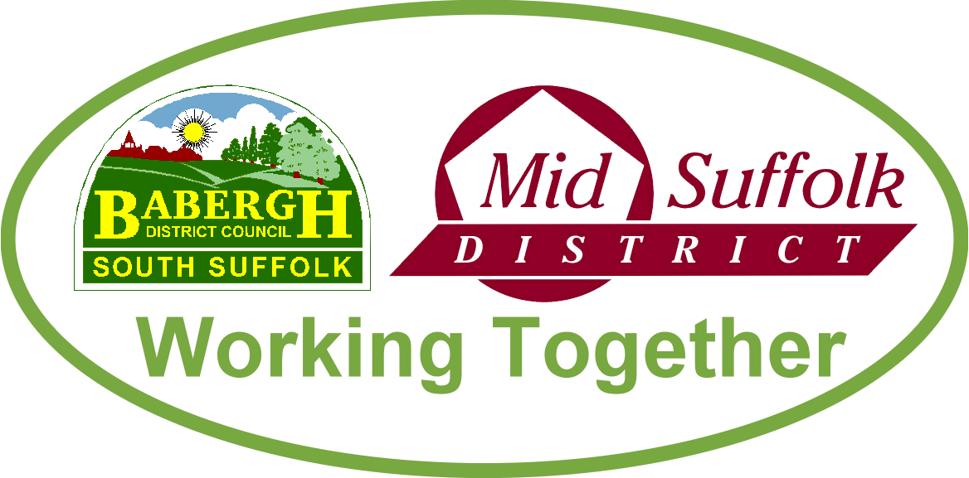

March 2023

Council tax freeze plus £2m for energy saving measures
Mid Suffolk District Council has confirmed a council tax freeze for residents and ring-fenced £2m for household energy-saving measures for those most in need, despite rising costs and increased demands on services. More information

New £12m depot would ‘future-proof’ services for residents
Babergh and Mid Suffolk District Councils are exploring plans to consolidate three aging operational sites into a shared £12m depot – future-proofing services for residents and improving conditions for their staff. More information

New service aims to turn more than 1,000 empty houses into homes
With over a thousand homes across Babergh and Mid Suffolk districts currently classified as empty, ‘Houses4Homes’ encourages owners of vacant residential properties to come forward for advice and support in turning their property into a home for another family. More information

First look at culture, heritage and visitor economy strategy for Babergh and Mid Suffolk
The first steps towards a dedicated cultural, heritage and visitor economy strategy could be taken should proposals be approved by Babergh and Mid Suffolk District Councils’ cabinets in March. More information

Food network approved to help people through cost-of-living challenges
Action to support even more people through the cost-of-living challenges will be taken in Suffolk as food bank usage rises. More information

VCFSE Resilience Fund: Councils launch third sector funding ‘lifeline’
Babergh and Mid Suffolk District Councils are delivering vital support to incredible organisations already helping those in our communities most exposed to the cost-of-living crisis. More information

Target to end rough sleeping in Suffolk
Suffolk’s public sector leaders, including those from Babergh and Mid Suffolk, are targeting an end to rough sleeping across the county by 2027. More information

Suffolk’s Exemplary Commitment to Retrofitting Homes
Commendable efforts are being made across Suffolk to ensure the retrofit of energy inefficient homes. More information

Suffolk councils secure £2.2m to improve tenants’ quality of life
Suffolk’s district and borough councils have secured £2.2m of Government funding to improve the standard of private rented homes in the county – tackling poor housing conditions and improving tenants’ wellbeing. More information

Gateway 14 officially opens main estate road
Mid Suffolk District Councillors joined representatives from Jaynic, town and parish councillors and partners involved in the Gateway 14 development for a ribbon cutting ceremony to officially open the first road on the site built by the infrastructure contractor Jackson Civil Engineering Ltd. More information

Community supports Chairman’s Civic Service
Civic dignitaries from across Suffolk joined Mid Suffolk District Council’s Chairman and local community representatives for a special service at St Mary’s the Virgin Church in Bramford earlier this month. More information

Babergh and Mid Suffolk District Councils’ Land Charges team shortlisted for new national award
Babergh and Mid Suffolk District Councils are in the running for a national award, for making a critical step in the house buying process as easy as possible for residents. More information

Half-term activities for schoolchildren in Babergh and Mid Suffolk
A week of swimming, sports and fun activities for children of all ages was staged for half term in Babergh and Mid Suffolk. More information

Supporting the elections this May
As you will know, the local and parish elections are due to be held on Thursday 4 May. You can see a full election timetable on our website.

- Voter registration
We will be supporting the Electoral Commission’s ‘Got 5?’ campaign running through March and April to raise awareness of upcoming elections and drive voter registration. The Commission will be advertising across a combination of channels including TV, radio, posters, social media, website banners, cinema advertising, and Google search. We will also be sharing the messages through the council’s social media channels and invite our towns and parishes to do the same.

- Staffing
There are still positions that need to be filled to ensure the elections are run smoothly across the districts. If you want to get involved, or know someone else who is interested please see our website or email the Babergh and Mid Suffolk elections team to find out more.

- Voter ID
The UK Government has introduced a requirement for voters to show photo ID when voting at a polling station, which will be implemented in the upcoming local and Parish elections in May. More information. We will continue to support the Electoral Commission’s national awareness campaign through all available council channels and ask that you also help where possible. You can find Electoral Commission resources, including posters and social media, here: Voter ID resources | Electoral Commission

- Webinar by the Electoral Commission
The Electoral Commission is hosting a pre-election webinar on Tuesday 7 March 2023 at 12pm – 1pm for candidates and agents taking part in the upcoming elections.
The webinar will provide an opportunity to gain essential information on the nomination process and the spending and donation rules, including information on:
- standing for election
- the nominations process
- when the spending rules apply
- how much you can spend
- notional spending rules
- who you can accept donations from
- what you need to report after the election

There will also be a chance to ask questions. To confirm attendance please email Stuart Butler on sbutler@electoralcommission.org.uk
For those unable to attend, we understand the Commission plans to publish slides from the webinar after the event.

